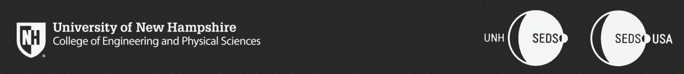  
  
CEPS Student Organization Budget Request  
**UNH Students for the Exploration and Development of Space**

To the CEPS Office of the Dean,

This year marks UNH SEDS’ 3rd year being an organization on campus and within CEPS. We have fostered a community of space-loving students within our home of Kingsbury S172 as well as within our community in CEPS, UNH and the surrounding community. We have hosted 13 senior projects within EE, CE, and ME in just two years. We have competed nationally in a rocketry competition (placing 5th overall!) and won 2nd place at the URC in both the ME Competition Team category and EE research. We have successfully designed, manufactured and tested a hybrid rocket engine in preparation for the Spaceport America Cup Competition in June 2020 and will continue to optimize it throughout this year (we even ran tests over the summer). We have attended a conference in San Diego, California (SpaceVision) that allowed the team to network and learn from other space-loving students within our nationwide organization. Lastly, and most importantly, we have created a community that is not reset year-to-year based on senior projects, but is run by all majors and years to create a growing, incredibly inspiring family of students not in the organization based on school requirements, but because of the passion.

Over this school year, we have easily tripled the working power from the two previous years combined. This is because we have confirmed the addition of 16 senior project into this year’s team, including eight mechanical, four electrical, two computer science majors and two civil engineers. Not to mention that the growing members using this organization as their senior project have been in the club since the start. Attached onto this letter is this year’s sponsorship package (primarily for company sponsorship), but shows an overview of the projects we are focusing on. Within our budget sheet, we took the liberty to explain each section/sub-section to ensure you understand the ‘why’ of each objective and how the resources listed are critical for its completion. In addition, more than half of the funds we have within out budget contribute to attending two conferences and our competition this year. Last year, SpaceVision was the only travel we did, all of which was self-funded by the 16-team members that decided to go (around 600 dollars for each student). It was an amazing experience, and even more of us are excited about returning this year with much more on our belt to share within the SEDS community. The primary way we can attend these conferences and competitions is with the support from the school, as companies are more interested in supporting engineering projects. It is also important to note here that machining expenses are not listed in the budget as we are confident that the relationships we have currently with companies will allow us to utilize the machines and machining time we need for our parts.

For the reason above, we have chosen to ask the CEPS Office of the Dean $**11,101.40** to support the 16 members currently (and expecting four new members to travel, as well) to attend SpaceVision. It is not only an amazing opportunity for all the students to network with passionate students around the country, but we are given the chance to network with the top aerospace companies in the world, including Blue Origin, SpaceX, Virgin Orbit and Rocket Lab, which is something you cannot do in the northeast. Many of us struggled greatly to obtain the funds needed individually attend last year, as we knew it was a career-changer, and the support of the school would show the importance the school puts to allowing their students to open their careers to new, exciting opportunities. The commercial space industry is currently the hardest engineering industry to get into (~1%), and meeting the right people is part of the game. It is a necessity for not a well-known school like UNH in terms of engineering.

If there are any questions within this packet of information on the story of SEDS and our goals, please do not hesitate to contact the team or myself.

Sincerely,

Charlie Nitschelm